**Project Development Phase**

**Model Performance Test**

|  |  |
| --- | --- |
| Date | 10 November 2022 |
| Team ID | Team-592275 |
| Project Name | Gilded Emotions: Unearthing Market Sentiments In Gold News |
| Maximum Marks | 10 Marks |

**Model Performance Testing:**

Project team shall fill the following information in model performance testing template.

|  |  |  |  |
| --- | --- | --- | --- |
| **S.No.** | **Parameter** | **Values** | **Screenshot** |
|  | Model Summary | **Model: SVM with TF-IDF Vectorizer** | [SC-1] in the next page |
|  | Accuracy | Training Accuracy: 0.966616841056303  Validation Accuracy: 0.9186361875242154 |  |
| 3. | Confidence Score (Only Yolo Projects) | Class Detected -   Confidence Score - |  |

|  |  |  |  |
| --- | --- | --- | --- |
| **S.No.** | **Parameter** | **Values** | **Screenshot** |
|  | Model Summary | **Model:Logistic Regression model with TF-IDF Vectorizer** | [SC-2] in the next page |
|  | Accuracy | Testing Accuracy: 0.924835335141418  Validation Accuracy: 0.924835335141418 |  |
| 3. | Confidence Score (Only Yolo Projects) | Class Detected -   Confidence Score - |  |

**[SC-1]Model: SVM with TF-IDF Vectorizer [SC-2] Model:Logistic Regression model with TF-IDF Vectorizer**

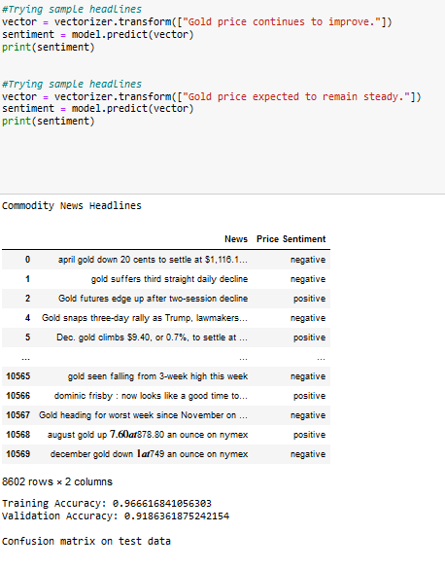

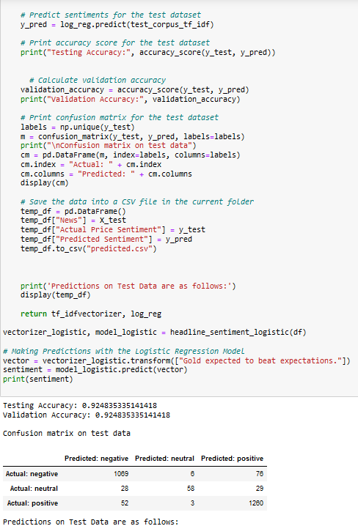

Validation Accuracy: 0.9186361875242154

Validation Accuracy: 0.924835335141418

Testing Accuracy: 0.924835335141418

Training Accuracy: 0.966616841056303

**Model: SVM with TF-IDF Vectorizer**

#Load packages

import numpy as np

import pandas as pd

from sklearn.feature_extraction.text import TfidfVectorizer

from sklearn.model_selection import train_test_split

from sklearn.metrics import accuracy_score, f1_score, recall_score, precision_score, confusion_matrix

from sklearn.svm import SVC

import re

df = pd.read_csv("gold-dataset-sinha-khandait.csv")

#Let us ignore the news headlines that do not have any price movement information in it, i.e. drop rows with "Price Sentiment" as 'none'

df = df[df["Price Sentiment"] != 'none']

print("Commodity News Headlines")

display(df[["News","Price Sentiment"]])

#The following piece of code is used to clean the headlines

def cleaner(impure_data):

temp_list = []

for item in impure_data:

#finding words which start with @

item = re.sub('@\S+', '', item)

#finding words which start with http

item = re.sub('http\S+\s*', '', item)

#finding special characters, but not "emoji"

item = re.sub('[%s]' % re.escape("""!"#$%&'()*+,-./:;<=>?@[\]^_`{|}~"""), '', item)

temp_list.append(item)

return temp_list

# Function to calculate accuracy

def calculate_accuracy(model, X, y):

y_pred = model.predict(X)

accuracy = accuracy_score(y, y_pred)

return accuracy

# Updated headline_sentiment function

def headline_sentiment(df):

headlines = df["News"]

polarity = df["Price Sentiment"].tolist()

# Cleaning headlines i.e. removing @mentions, http(s) links and special characters such as punctuations

clean_headline = cleaner(headlines)

# Initializing tf-idf vectorizer

tf_idfvectorizer = TfidfVectorizer(sublinear_tf=True, use_idf=True)

# Splitting the data into train and test dataset in 70:30 ratio at random

X_train, X_test, y_train, y_test = train_test_split(clean_headline, polarity, test_size=0.3)

train_corpus_tf_idf = tf_idfvectorizer.fit_transform(X_train)

test_corpus_tf_idf = tf_idfvectorizer.transform(X_test)

# Using SVC package to initialize a classifier with Linear kernel and other default parameters

SVM_L = SVC(kernel='linear')

# Fitting the sparse matrix in the classifier with their respective sentiments

SVM_L.fit(train_corpus_tf_idf, y_train)

# Calculate training accuracy

training_accuracy = calculate_accuracy(SVM_L, train_corpus_tf_idf, y_train)

# Calculate validation accuracy

validation_accuracy = calculate_accuracy(SVM_L, test_corpus_tf_idf, y_test)

# This prints accuracy score for the test dataset

print("Training Accuracy:", training_accuracy)

print("Validation Accuracy:", validation_accuracy)

# This prints confusion matrix for the test dataset

labels = np.unique(y_test)

m = confusion_matrix(y_test, SVM_L.predict(test_corpus_tf_idf), labels=labels)

print("\nConfusion matrix on test data")

cm = pd.DataFrame(m, index=labels, columns=labels)

cm.index = "Actual: " + cm.index

cm.columns = "Predicted: " + cm.columns

display(cm)

# Saving the data into a csv file in the current folder

temp_df = pd.DataFrame()

temp_df["News"] = X_test

temp_df["Actual Price Sentiment"] = y_test

temp_df["Predicted Sentiment"] = SVM_L.predict(test_corpus_tf_idf)

temp_df.to_csv("predicted.csv")

print('Predictions on Test Data are as follows:')

display(temp_df)

return tf_idfvectorizer, SVM_L

# Testing the model

vectorizer, model = headline_sentiment(df)

# Looking at the confusion matrix, it is clear that the performance on neutral will be poor.

# Positive and negative headlines are likely to be identified correctly

# Testing the model

vector = vectorizer.transform(["Gold expected to beat expectations."])

sentiment = model.predict(vector)

print(sentiment)

#Trying sample headlines

vector = vectorizer.transform(["The price of gold continues declining."])

sentiment = model.predict(vector)

print(sentiment)

#Trying sample headlines

vector = vectorizer.transform(["Gold price continues to improve."])

sentiment = model.predict(vector)

print(sentiment)

#Trying sample headlines

vector = vectorizer.transform(["Gold price expected to remain steady."])

sentiment = model.predict(vector)

print(sentiment)

**Model : Logistic Regression model with TfidfVectorizer**

import numpy as np

import pandas as pd

from sklearn.feature_extraction.text import TfidfVectorizer

from sklearn.model_selection import train_test_split

from sklearn.metrics import accuracy_score, confusion_matrix

from sklearn.linear_model import LogisticRegression

import re

df = pd.read_csv("gold-dataset-sinha-khandait.csv")

df = df[df["Price Sentiment"] != 'none']

# Data Preprocessing

def cleaner(impure_data):

temp_list = []

for item in impure_data:

# Apply cleaning steps (remove mentions, links, special characters, etc.)

item = re.sub('@\S+', '', item)

item = re.sub('http\S+\s*', '', item)

item = re.sub('[%s]' % re.escape("""!"#$%&'()*+,-./:;<=>?@[\]^_`{|}~"""), '', item)

temp_list.append(item)

return temp_list

# Create a Logistic Regression Model

def headline_sentiment_logistic(df):

headlines = df["News"]

polarity = df["Price Sentiment"].tolist()

# Clean headlines

clean_headline = cleaner(headlines)

# Initialize tf-idf vectorizer

tf_idfvectorizer = TfidfVectorizer(sublinear_tf=True, use_idf=True)

# Split data into train and test

X_train, X_test, y_train, y_test = train_test_split(clean_headline, polarity, test_size=0.3)

# Transform headlines using tf-idf

train_corpus_tf_idf = tf_idfvectorizer.fit_transform(X_train)

test_corpus_tf_idf = tf_idfvectorizer.transform(X_test)

# Initialize Logistic Regression model

log_reg = LogisticRegression()

# Fit the model with training data

log_reg.fit(train_corpus_tf_idf, y_train)

# Predict sentiments for the test dataset

y_pred = log_reg.predict(test_corpus_tf_idf)

# Print accuracy score for the test dataset

print("Testing Accuracy:", accuracy_score(y_test, y_pred))

# Calculate validation accuracy

validation_accuracy = accuracy_score(y_test, y_pred)

print("Validation Accuracy:", validation_accuracy)

# Print confusion matrix for the test dataset

labels = np.unique(y_test)

m = confusion_matrix(y_test, y_pred, labels=labels)

print("\nConfusion matrix on test data")

cm = pd.DataFrame(m, index=labels, columns=labels)

cm.index = "Actual: " + cm.index

cm.columns = "Predicted: " + cm.columns

display(cm)

# Save the data into a CSV file in the current folder

temp_df = pd.DataFrame()

temp_df["News"] = X_test

temp_df["Actual Price Sentiment"] = y_test

temp_df["Predicted Sentiment"] = y_pred

temp_df.to_csv("predicted.csv")

print('Predictions on Test Data are as follows:')

display(temp_df)

return tf_idfvectorizer, log_reg

vectorizer_logistic, model_logistic = headline_sentiment_logistic(df)

# Making Predictions with the Logistic Regression Model

vector = vectorizer_logistic.transform(["Gold expected to beat expectations."])

sentiment = model_logistic.predict(vector)

print(sentiment)